

Yearly Performance Targets
Hacı Şimşek

Manager: Osman YALIN
Turkish Web Team

2025

Table of Contents
1. Real-Time Order Processing and Messaging System 2
1.1 Analyze 3
1.2 Timeline – ETA 3
1.3 Project Details 3
1.4 Tech Stack 5
1.5 Gains 5

Real-Time Order Processing and Messaging System
  - Analyze
This project aims to provide a fully functional microservice-based architecture to process high-volume orders and notifications in real time in a single 20-week phase. The solution will adopt an event-driven design that encompasses supporting infrastructure such as order acquisition, processing, notification delivery, reporting and caching, messaging, containerization, and monitoring.
Redis will be used for high-speed data caching, RabbitMQ will handle inter-service communication, job queue management, and message routing. PostgreSQL will serve as the primary database. The system will be designed from day one with scalability, security, and ease of maintenance in mind.
  - Timeline – ETA
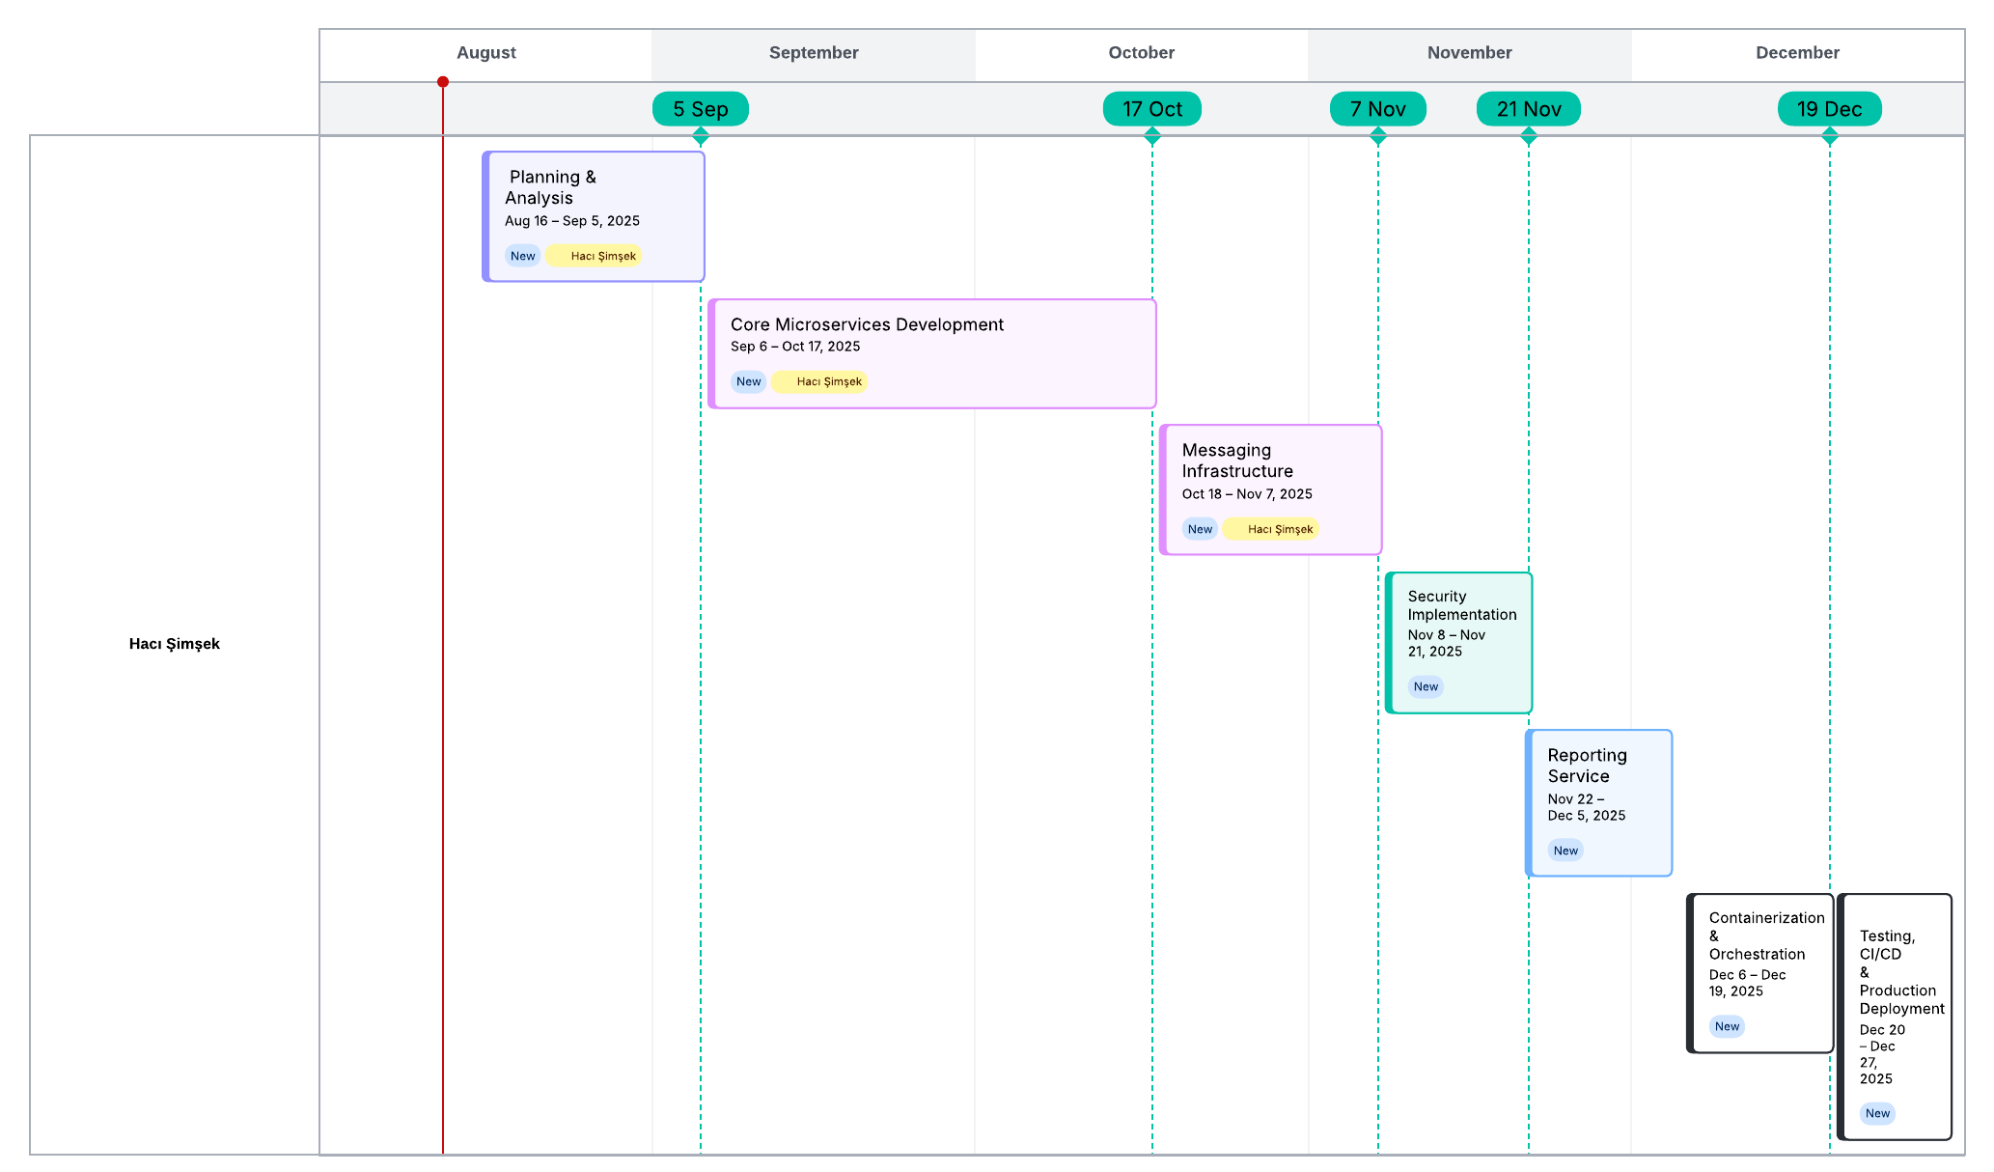

  - Project Details
1. Planning & Analysis – Aug 16 – Sep 5, 2025 (3 Weeks)
- Project kickoff and requirements gathering
- Finalize full project scope and delivery milestones
- Set up development environment (Java/Spring Boot, PostgreSQL, Redis, RabbitMQ)
- Architecture design: Microservices + CQRS + Event-driven
2. Core Microservices Development – Sep 6 – Oct 17, 2025 (6 Weeks)
- Order Management Service: CRUD operations, status workflow management
- Notification Service: Email, SMS, and push notification delivery
- Inventory Service: Real-time stock updates
- PostgreSQL schema design and integration
- RESTful API development
- Unit testing and error handling implementation
3. Messaging Infrastructure – Oct 18 – Nov 7, 2025 (3 Weeks)
- RabbitMQ setup and configuration
- Exchange, queue, and binding definitions
- Event publish/subscribe integration
- Retry logic, Dead Letter Queue (DLQ) management, and idempotency handling
4. Security Implementation – Nov 8 – Nov 21, 2025 (2 Weeks)
- JWT-based authentication
- RBAC (Role-Based Access Control) for user roles and permissions
- API Gateway security enforcement (rate limiting, request validation)
5. Reporting Service – Nov 22 – Dec 5, 2025 (2 Weeks)
- Daily, weekly, and monthly reporting using PostgreSQL
- JSON/CSV export capabilities
- Dashboard interface for report visualization
6. Containerization & Orchestration – Dec 6 – Dec 19, 2025 (2 Weeks)
- Dockerizing all services
- Orchestration using Docker Compose and Kubernetes (Minikube)
- Monitoring and alerting setup with Prometheus and Grafana

7. Testing, CI/CD & Production Deployment – Dec 20 – Dec 27, 2025 (1 Week)
- Integration, load, and performance testing (throughput, latency, error rate)
- CI/CD pipeline implementation with GitHub Actions
- Full operational documentation
- Production go-live

  - Tech Stack
- Backend: Java (Spring Boot)
- Database: PostgreSQL
- Messaging: RabbitMQ
- Caching: Redis
- Architecture: Microservices, CQRS, Event-driven
- Containerization: Docker, Kubernetes (Minikube)
- Security: JWT, RBAC
- CI/CD: GitHub Actions
- Monitoring: Prometheus, Grafana

  - Gains
A software developer aiming to leverage and enhance technical expertise by utilizing technologies adopted within the team, integrating them with new tools to create robust, secure, and scalable infrastructures. Experienced in the end-to-end lifecycle of microservice-based systems — from design and development to deployment and maintenance — capable of processing high-volume data streams with low latency using technologies such as RabbitMQ, PostgreSQL, Redis, Docker, and Kubernetes (Minikube). Skilled in designing relational schemas and analytics workflows, applying JWT and RBAC for secure role-based access control, and implementing containerization, orchestration, CI/CD pipelines, and system observability to ensure scalability, maintainability, and production readiness.

